Mini-Business Requirement Document - Office 365 Hybrid Mode

Kartik Velede

8672807

INFO8860 – Customer Needs and Analysis Gathering

Professor Janelle Mifflin Starkey

ASSIGNMENT START DATE: SEPT-26-2019

ASSIGNMENT DUE DATE: Oct-23-2019

**Table of Contents**

**1.Document History** 3

**2.Executive Summary** 3

**3.Key Stakeholders** 3

**4.Requriment Gathering** 4

**5.Project Description** 5

**6.Project Scope Deliverables** 5

**6.1 In Scope** 6

**6.2 Out Scope** 6

**7.Business Objectives** 7

**7.1 Enhanced scalability as your business grows** 7

**7.2 Accessibility: Anywhere and Anytime** 7

**7.3 Lower upfront cost or Reduced cost** 8

**7.4 Better Security Against Phishing and Data Theft** 10

**8.Current Process** 10

**9.Propsed Process** 10

**10.** **Functional Requirements** 12

**10.1 Priority** 12

**10.2 Requirements category** 13

**11.Non-functional requirements** 14

**12.User stories** 14

**13.References** 16

# **1.Document History**

|  |  |  |  |
| --- | --- | --- | --- |
| Version | Date | Changes | Author |
| 1 | 22/10/2019 | Migration to office 365 | Kartik Velede |

# **2.Executive Summary**

VSN company is currently using on-premise office for storing and exchanging documents. This faces many problems when using local office facilities, such as licenses, updating of features, backup of data, slower data processing, accessibility and higher upfront cost. In order to provide the solution to these problems and decrease the upfront cost of an organization, I would recommend Office 365 is the best possible solution.

This document provides detailed explanation of migrating from local office to office 365 in a step by step manner. Once the elicitation process is complete, I recommend that office 365 is the best solution for data storage, email exchange, data server, team collaboration. My manger would like this done in two phases, with phase 1 being a test pilot trial of 25 users. That means that this project will be in a Hybrid mode (part on premise and trial users in Cloud). When phase 1 has been successfully completed. Now we can go ahead and plan the migration of remaining 125 employees in an organization.

# 

# **3.Key Stakeholders**

Stake holders are the executive sponsors of project and take part in the project development. Stakeholders might be from within the organization or outside the organization.

The key stakeholder for VSN company

|  |  |
| --- | --- |
| **Name** | **Designation** |
| Janelle Mifflin Starkey | Business Analyst |

# **4.Requriment Gathering**

Requirement gathering plays a prominent role in a project in order the to understand the needs of the project from various users and other stakeholders

Following are some of the elicitation done from the employees of the organization in order to understand the issues and to find out the solution by gathering feasible data

**Question 1:** What is the count of employees in your organization?

**Answer:** The total number of employees are around 200

**Question 2:** How do you share or access documents in your organization?

**Answer:** We share the documents across emails

**Question 3**: What is the maximum size of document you share?

**Answer:** The maximum size of the document varies from 100MB to 1GB

**Question 4**: How frequently the documents are shared within the organization?

**Answer**: The documents are shared instantly when the request is made

**Question 5**: Can the documents be accessed outside the organization?

**Answer**: Documents cannot be accessed outside the organization.

**Question 6:** Where do you store the documents in your organization? Do you have a backup for your documents?

**Answer**: Documents are stored on the desktop and there is no backup space for documents

**Question 7:** Does the organization has efficient IT Technical Team in order to resolve the errors?

**Answer**: Yes, organization has expertise IT team, who is available 24X7 shifts to provide the resolutions

# **5.Project Description**

FSX business seeks consultants to help them introduce and migrate to office 365.The vendor or consultants try to understand the existing problem and gather all the requirements in order to deliver a successful migration .The following are some of services provided by the vendor for migrating into cloud such email services, data repository, data security and also providing secure access to cloud

# **6.Project Scope Deliverables**

The project is going to be in hybrid mode with test trail experiment of 25 employees on cloud and with 125 employees on-premise

All the 25 employees who are migrating from local to cloud belongs to following departments (IT ,Sales and Marketing , HR, R and D , Operations) and 5 person from each department with department head among them will be migrated in order to test and validate the working condition of each department. The following are some of the functions to be migrated

1. All the existing emails get migrated to email exchange server
2. All the previously stored data in the local office gets migrated to SharePoint
3. Migration of data backup

## **6.1 In Scope**

The following areas are in scope for this project

* Outlook
* SharePoint
* OneDrive
* Teams
* People
* Forms
* Calendar

## **6.2 Out Scope**

The following areas area out scope for this project

* Delve
* Yammer
* Planner
* Flow

# **7.Business Objectives**

The following are some of the reason for the organization to initiate this project i.e. migrating to Office 365

* Enhanced scalability as your business grows
* Accessibility: Anywhere and Anytime
* Lower upfront cost or Reduced cost
* Better Security Against Phishing and Data Theft

## **7.1 Enhanced scalability as your business grows**

Many organizations underlying objective is scalability. You need to make sure that any software solution you introduce will expand the business without adding new problems to it. While using the local office the company faced many problems like purchasing office to all the individual users whereas in office 365 we can simply add multiple users to singe subscription of office.

## **7.2 Accessibility: Anywhere and Anytime**

By storing everything on Microsoft’s servers, Office 365 gives employees an easy access to documents no matter where they go. This will increase the work efficiency of the employees.

## **7.3 Lower upfront cost or Reduced cost**

Although small businesses may need to pay large front-end costs per client for Office, Office 365 can provide you with a better deal. You eliminate the cost of buying new servers when you use cloud-based office 365 services and also will decrease the number of employees who maintain the server

Below cost comparison table depicts the overall reduction of cost in an organization

|  |  |  |  |  |  |
| --- | --- | --- | --- | --- | --- |
|  |  |  | **Total** | |  |
|  | **Quantity** | **Cost** | **Start Up** | **Recurring** | Frequency |
| Office 2013 Licence | 25 | 400 | 12,000 |  | 1-Time |
| User Hardware | 25 | 800 | 24,000 |  | 1-Time |
| User Software (Windows) | 25 | 259 | 7,770 |  | 1-Time |
| Email Service |  |  |  |  |  |
| Server Hardware | 1 | 1,000 | 1,000 |  | 1-Time |
| Server Software | 1 | 995 | 995 |  | 1-Time |
| Electricity Costs | 1 | 5 | 5 | 60 | Monthly |
| Space (Sq-Ft) | 5 | 10 | 50 | 600 | Monthly |
| NAS (32TB) | 1 | 2,100 | 2,100 |  | 1-Time |
| Internet (20mb/s) | 1 | 60 | 60 | 720 | Monthly |
| IT Staff | 3 | 60,000 |  | 180,000 | Year |
| **Total** |  | **65,629** | **47,980** | **181,380** |  |

**Figure (1) Current Cost**

|  |  |  |  |  |  |
| --- | --- | --- | --- | --- | --- |
|  |  |  | **Total** | |  |
|  | **Quantity** | **Cost** | **Start Up** | **Recurring** | Frequency |
| Office 2013 Licence | 0 | 400 | - |  | 1-Time |
| User Hardware | 28 | 800 | 22,400 |  | 1-Time |
| User Software (Windows) | 28 | 259 | 7,252 |  | 1-Time |
| Email Service |  |  |  |  |  |
| Server Hardware | 0 | 1000 | - |  | 1-Time |
| Server Software | 0 | 995 | - |  | 1-Time |
| Electricity Costs | 0 | 5 | - |  | Monthly |
| Space (Sq-Ft) | 0 | 10 | - |  | Monthly |
| NAS (32TB) | 0 | 21000 | - |  | 1-Time |
| Internet (60mb/s) | 1 | 100 |  | 1,200 | Monthly |
| IT Staff | 1 | 60000 |  | 60000 | Year |
| Office 365 Business Premium | 28 | 16 |  | 5376 | Monthly |
| Migration Costs | 28 | 250 | 7000 |  | 1-Time |
| **Total** |  | **84,835** | **29,652** | **61,200** |  |
|  |  |  |  |  |  |
|  |  |  |  |  |  |
|  |  |  |  |  |  |

**Figure (2) Future Cost**

By the doing the cost comparison we can understand that organization saves huge amount of investment.

## **7.4 Better Security Against Phishing and Data Theft**

The major problem within the small organization is lack of IT expertise in order to protect the important data of the organization. With Microsoft Office 365 we can get rid of this problem since Microsoft has highly skilled data expertise and advanced software tools to protect the sensitive data

# **8.Current Process**

To date, VSN company has used local office, the current process they follow are listed below

* Uses office 365 installed in desktops
* All Documents and contents are stored on a shared drive network
* Users access their email through MS outlook from an email pop/imap mail service
* There is no collaboration among the employees
* Ability to work and access files virtually is not present
* Feedback is taken through physical papers
* Company spends huge amount of investment on servers

# **9.Propsed Process**

VSN company has decide to migrate to cloud i.e Microsoft Office 365 in order to improve the business and work efficiency .Company boss has decided to do the migration process in two phase. In phase 1 a test trail pilot of 25 employees get migrated and after successful completion phase 2 migration gets stared that is for remaining 125 employees. Among these 150 employees 60 employees in the company have business provided mobile device and Not all your trial pilot users will have a company issued mobile device

Based on the elicitation performed Microsoft Office 365 Business Premium is the best solution

Th following are two migration that takes place

1. Email migration: All emails of 25 employees present on the local office gets migrated to Outlook Online
2. Data migration: All documents of 25 employees present on the local office gets migrated to SharePoint

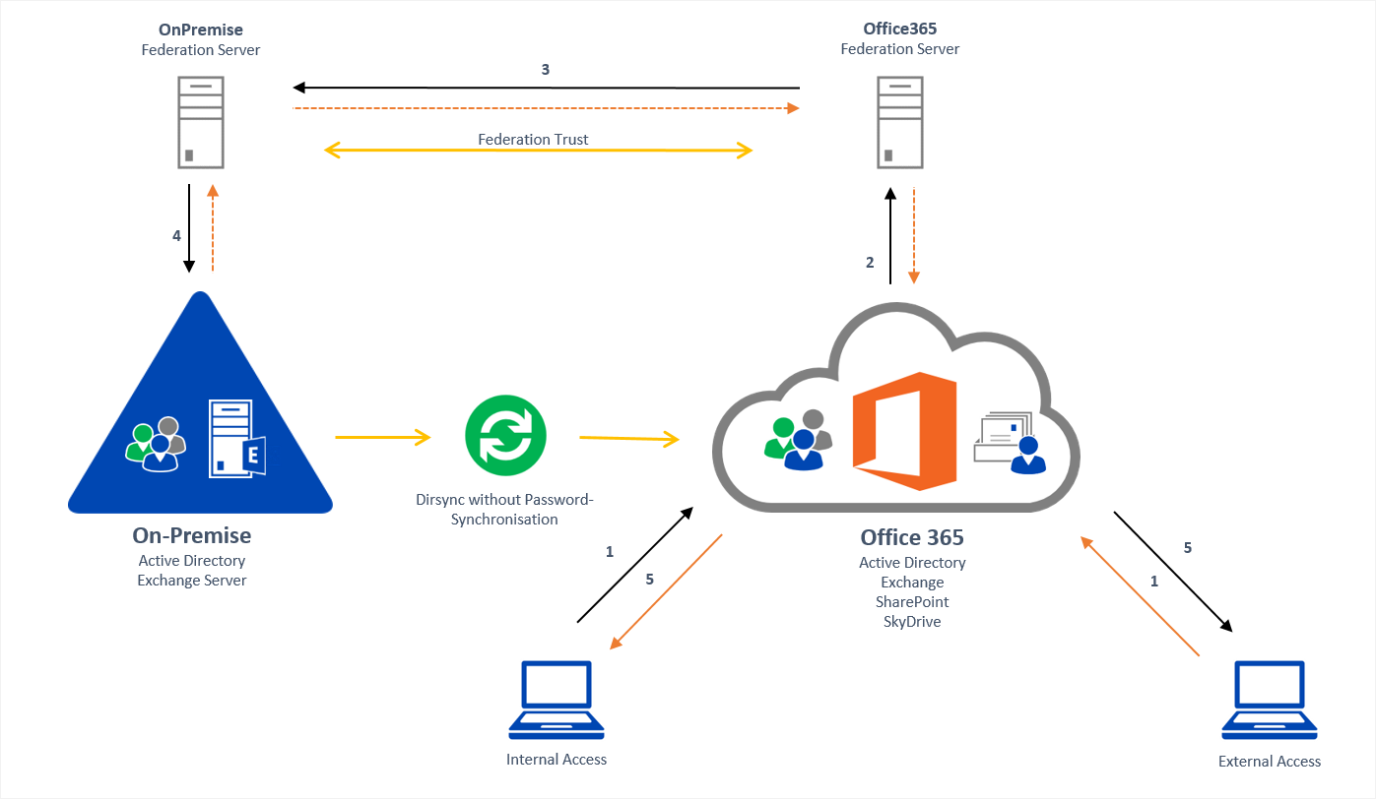

**Figure (3) Hybrid Mode of Office 365**

# **10.** **Functional Requirements**

This section will describe the functional requirements of the proposed project.

## **10.1 Priority**

|  |  |  |
| --- | --- | --- |
| Value | Rating | Description |
| 1.a  1.b | Critical-  Storage  Data security | Storage is the very important in order to complete successful migration  Confidential data needs to be protected with advanced software |
| 2.a  2.b | Medium-  Validating user login credentials  Collaboration | Verifying user data is important in order to protect the data of the organization  Collaboration is very important for user friendly working environment |
| 3.a | Low-  Accessibility of document  From mobile devices | In case of emergency mobile devices should have access to documents to share and edit |

## **10.2 Requirements category**

|  |  |  |
| --- | --- | --- |
| **ID** | **Requirement** | **Priority** |
| RQC1 | * Office applications * Huge data storage * High speed internet * Data security * Back up | 1 |
| RQC2 | * Calendars * Collaborations * Business Meetings | **2** |
| RQC3 | * Accessibility of document from mobile devices * One note | **3** |

# 

# **11.Non-functional requirements**

|  |  |
| --- | --- |
| **ID** | **Requirement** |
| NFR1 | Security- Verify login credentials, data classification, authentication, authorization levels |
| NFR2 | Availability- Designed to be highly available during normal working hours |
| NFR3 | Maintenance-Conformance to organization standards, best practices |
| NFR4 | Performance – for example Response Time, Throughput, Utilization, Static Volumetric |
| NFR5 | Reliability- Mean time between failures, how to protect from failures |
| NFR6 | Scalability- Typical and maximum number of concurrent users |

# **12.User stories**

|  |  |  |  |
| --- | --- | --- | --- |
| **Story ID** | **User class** | **User wants to** | **Outcome** |
| 1 | It support | Collaboration and communication of employees | Allows the users to chat and communicate with each other with a chat application called teams |
| 2 | Sales | Access to office apps on mobile | Allows to use office 365 applications on mobile so that virtual accessibility of applications can be possible |
| 3 | IT developer | Wants to know the feedback of the employees | Forms can be used create surveys, quizzes and take the feedback on the ongoing process |
| 4 | Admin team | Notifications of meetings and events | Calendar application allows to schedule meeting and set remainders |
| 5 | Active user | Work together | Allows all the team members together with the help of collaboration |
| 6 | Manager | Updating to latest versions | Microsoft Office 365 has an in-built auto update option which automatically gets updated to new versions |
| 7 | Active user | Email services | Outlook allows the employees to send and receive an email |
| 8 | Manager | Permissions | Permission are given based on the roles of an employee in an organization |

# **13.References**

|  |  |
| --- | --- |
| Name | Link |
| Business objectives | <https://www.agileit.com/news/migrate-google-office-365/>  https://okcitguys.com/3-reasons-your-business-should-migrate-to-office-365-email-migration/ |
| E-textbook | Karl Wiegers and Joy Beatty, 3rd ed, 2013 |